ROTHER A.C. VENUES
Cooks Pond, Milland Hants : GU30 7JY Lat Long: N51.030248 W0.814791
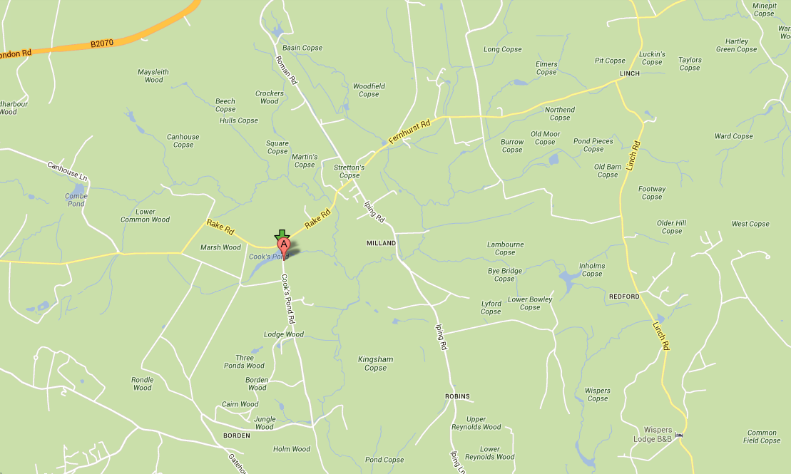
Approximately 4 acres. Parking only on the verge alongside the road. Please park sensibly and do not park opposite driveways . Fishing only from marked pegs. The fishery contains a good head of Crucian Carp, Tench, Roach, Perch Rudd and skimmer bream.
Water closed 1st Feb – 31st April. Strictly NO night fishing

New Pond, Bepton Road, Midhurst : GU29 9RD
Lat Long: N50.980088 W0.751491
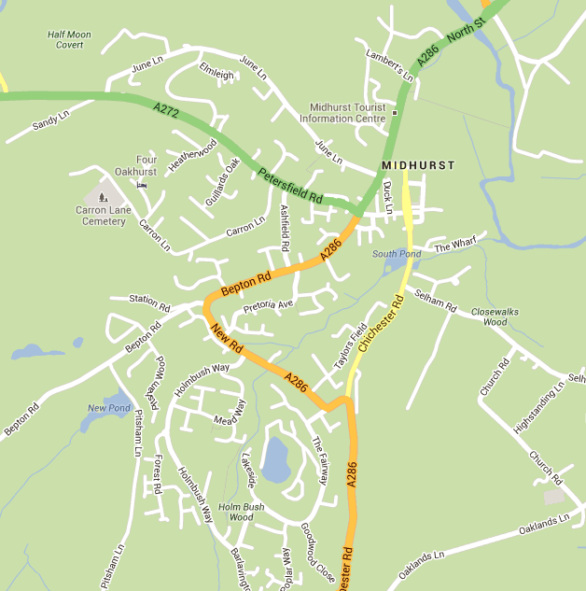
Approximately 2 acres. Parking past the pond on the right, Please park sensibly and leave room for others . Fishing only from marked pegs. The fishery contains a good head of Carp, Roach, Perch Rudd and skimmer bream.
NO floating baits.
Carp may not be retained in nets unless in bona-fide matches.

Rotherfield Pond, Dodsley Lane Easebourne Midhurst West Sussex
GU29 9AW Lat Long: N50.992099 W0.734665
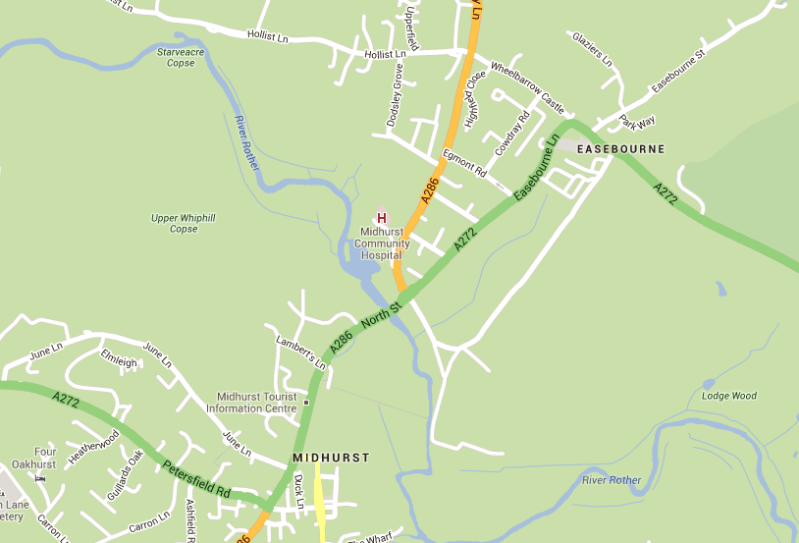
Approximately 1.5 acres. Access adjacent to entrance to Midhurst Community Hospital. (Map) Fishing is from permanent pegs only. Pegs on the north side of the river may also be fished from this point. The fishery contains a good head of Carp, Roach, Perch Rudd Pike Tench and bream.
Carp may not be retained in nets unless in bona-fide matches.

River Rother, North Mill, Dodsley Lane Easebourne Midhurst West Sussex
GU29 9AW Lat Long: N50.992099 W0.734665
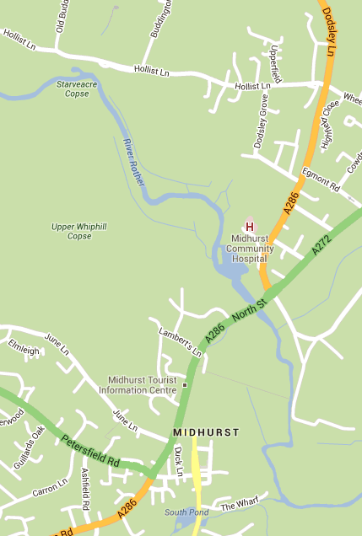
Approximately 3/4 mile of river upstream on North bank, including Mill Pool. Access is from Rotherfield Pond via a path along the North side and behind the medical centre grounds. (Part of the path is steep and can be slippery in wet conditions so please take care) This leads to a wooded area and then into a second field. Fishing from permanent pegs only. The fishery contains Carp, Roach, Dace Grayling Chub Perch Rudd Pike and bream.

River Rother, Woolbeding Midhurst West Sussex
Lat Long: N50.992802 W0.760621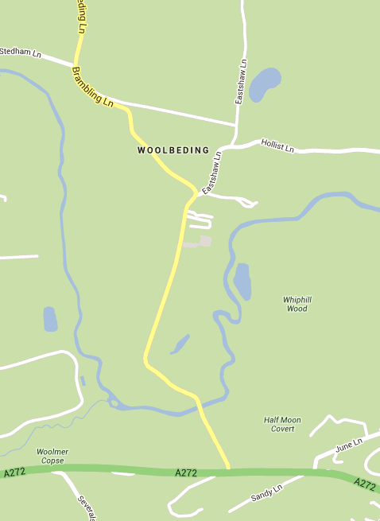
Approximately 1.5 miles upstream from Woolbeding bridge on north bank. Access only via permanant gates. Please keep all gates closed. Parking only on the grass verge on the right after the bend. (opposite the house) DO NOT PARK IN THE GATEWAYS Night fishing is NOT allowed… The fishery contains Roach, Dace Grayling Chub Perch Rudd and Pike.
This fishery is affected by overhead power lines. Exercise caution !!

River Arun, Greatham Bridge Brook Lane, Coldwaltham West Sussex
Lat Long: N50.936499 W0.534799
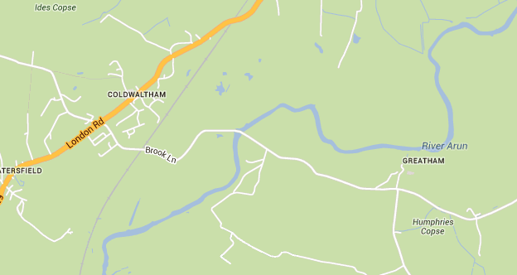
Approximately 0.5 mile west bank upstream of bridge (one field) Parking in car park by bridge only. Access to the upstream stretch is through the metal gate opposite the car park. (These gates must be kept locked at all times. The locks are combination coded and codes are available from pondlife67@googlemail.com on request. ) Access is strictly via the flood bank and river bank only. under no circumstances must members wander onto adjacent land. The fishery contains Carp, Roach, Dace Grayling Chub Perch Rudd Pike eels and bream.

Woolmer Stream: Lat-Long N50.989165,- W0.76664
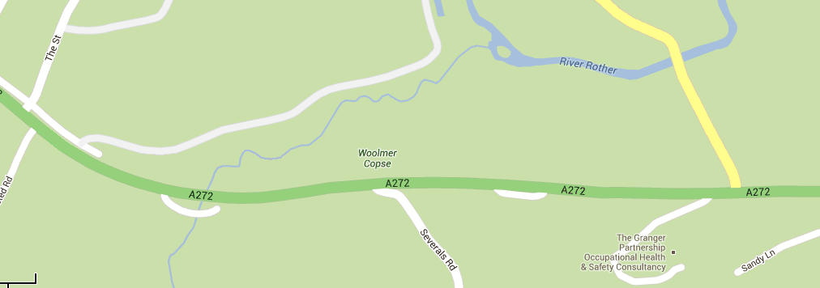
South bank only between bridge on A272 Midhurst – Petersfield Road and junction with River Rother. Parking in layby off A272 (Map) This heavily wooded stream is narrow and shallow with some deep pools and stretches. The fishery contains Roach, Dace Grayling Chub Perch Rudd and Pike.

North Mill Millpool GU29 9AW Lat Long: N50.992099 W0.734665
: 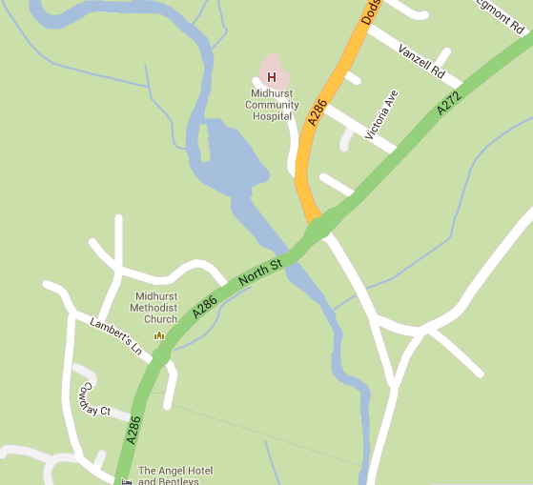
Parking is at Rotherfield Pond, Access via gate on the A272 road bridge, No access to Environment Agency fenced areas No fishing from walls either side of the weir. The fishery contains Roach, Dace Grayling Chub Perch Rudd Bream and Pike.

